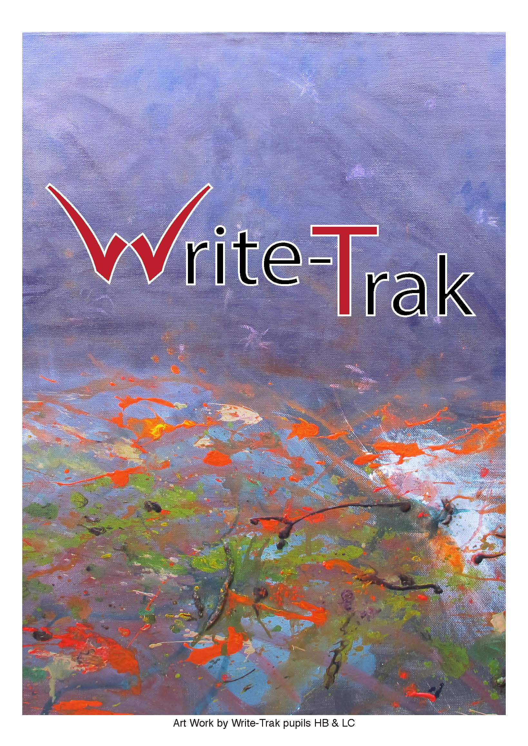
Welcome to Write-Trak

Write-Trak is a small and friendly independent tuition agency based throughout Kent and Medway. We specialise in educating young people who are between the ages of 10 - 19 years who have found it difficult to access a conventional school environment or have no appropriate school placement. Write-Trak works with young people who have social, emotional, behavioural and learning needs.

Write-Trak works in partnership with local authorities, schools, colleges and with other agencies concerned with education and the welfare of children.

Write-Trak offers an educational package that is a tailored and differentiated which includes core elements of the national curriculum and appropriate studies of other subjects.

Write-Trak tutors work from their own homes, five hours per day five days a week. The tutor groups are always small usually three or four students per tutor.
Each student follows an individual education plan tailored uniquely to meet their specific needs. This always includes Mathematics, English and Science and appropriate studies of other subjects.

Write-Trak is a registered Examination Centre where students are able to sit a variety of GCSE and Entry Level qualifications which include Mathematics, English, Science and Personal Social Education (PSE).

Write-Traks’ team monitors and co-ordinates the education of all children and young people placed with them. Each tutor is visited weekly by a support worker to ensure each student’s educational and social needs are met.

Write-Trak offers each student from year 9 tailored careers advice. All year 11+ pupils will receive intensive careers advice with a transition package into college/work based training.

Write-Trak offers College taster sessions at local College for year 10+ pupils throughout the year. The Write-Trak careers advisor will accompany students whilst at college. We are able to offer courses such as Bricklaying, Catering, Animal Care, Micro engineering, Motor Engineering, Construction and other selected courses, including Brogdale Farm.

Write-Trak has an excellent record of setting up successful college courses and school placements for our students who are ready to move on.

Write-Trak is committed to ensuring that all children and young people have access to education enabling them to realise their full potential.

Curriculum

Write-Trak aims to provide a tailored curriculum for every student based on their needs. Tutors help students to access the National Curriculum in English, Mathematics and Science at the appropriate Key Stage and Level.

Each student has both their pastoral and academic needs met by their individual programme. Curriculums are differentiated to meet the interests of the student, whilst still aiming to cover a broad base of topics.

Appropriate studies of other subjects are offered including; PHSE, CEOP (Child exploitation online protection), Geography, History, Cookery, Information Technology and Art.

Write-Trak encourages students to participate in a variety of activities, such as swimming, golf, sports centre activities and educational trips.

Write-Trak assesses all students on a regular basis using nationally recognised standardised tests.

Write-Trak provides full written reports on an annual basis. We use standardised assessments to measure progress as well as SATS style material. We attend Education Health and Care Plan reviews, LAC reviews and Personal Education Plan Meetings.

Public Examinations

Currently Write-Trak’s Key Stage 4 + students follow the courses shown below:

GCSE Mathematics
GCSE English
GCSE Biology
Level 1 Personal Social Education (PSE)
Entry Level Certificate Science
Entry Level Certificate English
Entry Level Certificate Mathematics
Entry Level Certificate History
Certificates in ICT
Other courses are offered dependant on student’s individual needs.

Our most recent inspection by the JCQ took place in 2019. Write-Trak passed this inspection.

Write-Trak registered examination centre is:

Write-Trak, Arrow Riding Centre, Darenth Park Avenue, Dartford, Kent, DA2 6LZ. Parents and carers are required to accompany their young person to and from the exam centre on the dates of their exams.

Post 16
Write-Trak offers a bespoke post 16 Package of Education, Training and alternative pathways to suite each student individual needs. We endeavour to create challenging and inspiring learning environments to encourage students to reach their full potential and follow their chosen career.

Careers Guidance

Write-Trak aims to ensure that every student has a career plan path to follow on leaving Write-Trak.

Write-Trak offers intensive careers support for our year 10 + students during tuition time. The role of the careers officer includes; Career Action Plan, arranging and accompany interviews and completing application forms. This all takes place in conjunction with parents/carers, with their consent.

The Write-Trak Team

Anna Turner-Bee is the Director of Write-Trak.

- Write-Trak has 15 dedicated and experienced tutors.

- Write-Trak staff and tutors are DBS checked every 3 years.

- Write-Trak has two tutoring support workers who visit each tutor weekly. Their unannounced visits ensure that excellent working practice is maintained and students’ wellbeing is monitored on a weekly basis.

- Write-Trak tutors work from their own homes and are fully insured and risk assessed regularly.

- Write-Trak Tutors are regular monitored and observed formally in order to maintain and improve tutoring standards by an external assessor.

- Write-Trak staff and tutors attend four formal training sessions every year, as well as tutor support meetings and tutor satellite meetings.

- Write-Trak Examinations Officer co-ordinates the Write-Trak Examination Centre in
Dartford.

Write-Trak’s Examination Centre is annually inspected by the JCQ (Joint Council for Qualifications) on behalf of the examination boards OCR and AQA.

How Does The Write-Trak Referral Process Work?

Please complete the Write-Trak referral form

- Once we receive a completed referral form, and funding has been agreed by the placing authority, Write-Trak will assess whether the applicant’s specific needs can be met.
- Write-Trak will arrange a home visit to discuss the student’s needs in greater depth. By meeting the student Write-Trak can assess which Tutor Group will be most suitable. This essential meeting is an opportunity to establish a positive working relationship between student, parent/carer and Write-Trak. This paves the way to a successful educational placement at Write-Trak.
- The next step is for Write-Trak to make a formal offer of a place. This is subject to a suitable vacancy being available, at times there may be a waiting list.
- Prior to joining Write-Trak each new student receives a starter pack including; contact book, home/Write-Trak agreement, consent forms, timetable, and tutor details.

NB. Write-Trak is not responsible for arranging transport to or from tutoring.

(Referral form enclosed at the back of this brochure)

Office Hours

Write-Trak offices hours are between 8.30am and 5pm on 01474 707479.
Outside office hours messages can be left.
Write-Trak aims to deal with any matters arising swiftly via telephone

Write-Trak
Anna Turner-Bee
Telephone/Fax: 01474 707479
Website Address: www.writetrak.co.uk
Email: anna.turner-bee@writetrak.co.uk
21 Kent Road
Longfield
Kent
DA37QR
Write-Trak Limited Reg in Wales No 3471574
Reg Office: Lot 12 Fawkham Manor, nr Longfield, Kent DA3 8ND

Write-Trak Ltd
21 Kent Road
Longfield
Kent
DA3 7QR
01474 707479
anna.turner-bee@writetrak.co.uk

Referring Agency: Date:
Contact Name:
Address:

Tel No:
email address:

NAME OF STUDENT:………………………………………………………...............................................

D.O.B: Year Group: Sex:

Parent/Carers details:
Name: Tel No.
Address: Mobile No:
email address:

Social worker: Tel No:
Local Authority email address:

- Is the young person currently in mainstream education?

- Brief educational history/Last school attended/How long out of education?

- Is the young person statemented / Educational Health Care Plan ? Yes/No

If yes please attach / send with referral

Primary area of Need....................................Secondary area of Need ........................

Date of last Annual Review / Date Annual Review due................................................

- Any other difficulties, e.g. physical handicap, learning disability:

- Behaviour problems? - please specify below.

- Brief outline of plan of placement: i.e. short/long term

- Is provision for 2/3/4 or 5 days?

- Is there any history of allegations? - If yes please provide details below

- Is funding Agreed?

- Invoice contact/address:

Tel No:
email address:

- Purchase Order No:

- Has transport been arranged/considered?

Areas of Concern | Y/N | Please provided details
Verbally aggressive
Physically aggressive
Substance/Alcohol misuse
Self-Harm
Offending/Police involvement
Allegations
Absconding
Attendance issues
Theft
Mental Health
Other - please specify

Any Further information:

By submitting this referral you are agreeing to Write-Trak Ltd terms and conditions which are available on the website and or on request.

